**fieldformat**

<http://docs.splunk.com/Documentation/Splunk/6.4.1/SearchReference/Fieldformat>

**Description**

With the fieldformat command you can use eval expressions to change the format of a field value when the results render. You can change the format without changing the underlying value of the field. Commands later in the search pipeline cannot modify the formatted value.

The fieldformat command does not apply to commands that export data, such as the outputcsv and output lookupcommands. The export retains the original data format and not the rendered format. If you want the format to apply to exported data, use the eval command instead instead of the fieldformat command.

**Syntax**

fieldformat <field>=<eval-expression>

**Required arguments**

**<field>**

**Description:** The name of a new or existing field, non-wildcarded, for the output of the eval expression.

**<eval-expression>**

**Syntax:** <string>

**Description:** A combination of values, variables, operators, and functions that represent the value of your destination field. For more information, see the [eval command](http://docs.splunk.com/Documentation/Splunk/6.4.1/SearchReference/Eval) and the [evaluation functions](http://docs.splunk.com/Documentation/Splunk/6.4.1/SearchReference/CommonEvalFunctions).

**Examples**

**Example 1:**

Return [metadata](http://docs.splunk.com/Documentation/Splunk/6.4.1/SearchReference/Metadata) results for the sourcetypes in the main index.

| metadata type=sourcetypes | rename totalCount as Count firstTime as "First Event" lastTime as "Last Event" recentTime as "Last Update" | table sourcetype Count "First Event" "Last Event" "Last Update"

The fields are also renamed, but without the fieldformat command the time fields display in Unix time:

[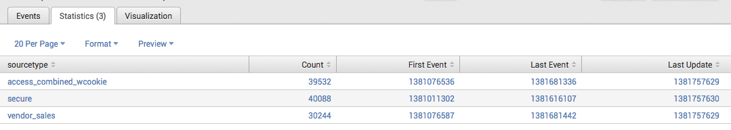](http://docs.splunk.com/File:Searchref_fieldformat_ex1.1.png)

Now use the fieldformat command to reformat the time fields firstTime, lastTime, and recentTime:

| metadata type=sourcetypes | rename totalCount as Count firstTime as "First Event" lastTime as "Last Event" recentTime as "Last Update" | table sourcetype Count "First Event" "Last Event" "Last Update" | fieldformat Count=tostring(Count, "commas") | fieldformat "First Event"=strftime('First Event', "%c") | fieldformat "Last Event"=strftime('Last Event', "%c") | fieldformat "Last Update"=strftime('Last Update', "%c")

Note that the fieldformat command is also used to reformat the Count field to display the values with commas. The results are more readable:

[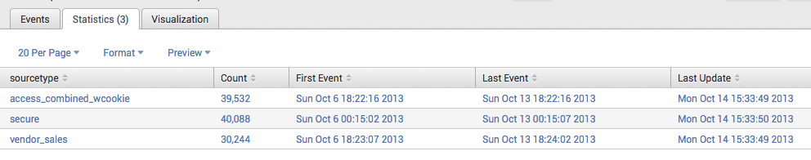](http://docs.splunk.com/File:Searchref_fieldformat_ex1.2.png)

**Example 2:**

Assuming that the start_time is an epoch number, render start_time to display just the hours minutes and seconds corresponding to that epoch time.

... | fieldformat start_time = strftime(start_time, "%H:%M:%S")

**Example 3:**

To format numerical values in a field with a currency symbol, you must specify the symbol as a literal and enclose it in quotation marks. Use a period character as a binary concatenation operator, followed by the tostring function, which enables you to display commas in the currency values.

...| fieldformat totalSales="$".tostring(totalSales,"commas")

**See also**

[eval](http://docs.splunk.com/Documentation/Splunk/6.4.1/SearchReference/Eval), [where](http://docs.splunk.com/Documentation/Splunk/6.4.1/SearchReference/Where)

**Answers**

Have questions? Visit [Splunk Answers](http://splunk-base.splunk.com/) and see what [questions and answers the Splunk community has using the fieldformat command](http://splunk-base.splunk.com/tags/fieldformat/).